A Project report on

## **Programming Spot**

A Dissertation submitted to JNTU Hyderabad in partial fulfillment of the academic requirements for the award of the degree.

Bachelor of Technology

in

Computer Science and Engineering

Submitted by

Nanigari Koushik - 20H51A05G2

Vennam Eshwar - 20H51A05G0 Bodrai Ravichandra - 20H51A05D7

Under the esteemed guidance of

Ms.T.Adarana Assistant Professor



Department of Computer Science and Engineering

CMR COLLEGE OF ENGINEERING & TECHNOLOGY

(An Autonomous Institution, Approved by AICTE, Affiliated to JNTUH, NAAC ’A+’)

KANDLAKOYA, MEDCHAL ROAD, HYDERABAD - 501401.

## 2020 - 2024

CMR COLLEGE OF ENGINEERING & TECHNOLOGY

KANDLAKOYA, MEDCHAL ROAD, HYDERABAD – 501401

DEPARTMENT OF COMPUTER SCIENCE AND ENGINEERING



## CERTIFICATE

This is to certify that the Project report entitled **“Programming Spot”**

begin submitted by **N.Koushik(20H51A05G2), V.Eshwar(20H51A05G0), B.Ravi chandra(20H51A05D7)** in partial fulfillment for the award of **Bachelor of Technology in Computer Science and Engineering** is a record of bonafide work carried out his/her under my guidance and supervision.

The results embodies in this project report have not been submitted to any other University or Institute for the award of any Degree.

Ms.T.Adarana Dr. S. Siva Skandha

Assistant Professor Associate Professor and Head

Dept. of CSE Dept. of CSE

## Acknowledgement

With great pleasure we want to take this opportunity to express our heartfelt gratitude to all the people who helped in making this project work a grand success.

we are grateful to Ms.T.Adarana, Assistant professor, Dept of Computer Science and Engineering for her valuable suggestions and guidance during the execution of this project work.

We would like to thank Dr. S.Siva Skandha, Head of the Department of Computer Science and Engineering, CMR College of Engineering and Technology, who is the major driving forces to complete my project work successfully.

We are very grateful to Dr. Vijaya Kumar Koppula, Dean-Academic, CMR College of Engineering and Technology, for his constant support and motivation in carrying out the project work successfully.

We are highly indebted to Dr. V A Narayana, Principal, CMR College of Engineering and Technology, for giving permission to carry out this project in a successful and fruitful way.

We would like to thank the Teaching & Non- teaching staff of Department of Computer Science and Engineering for their co-operation

Finally we express our sincere thanks to Mr. Ch. Gopal Reddy, Secretary, CMR Group of Institutions, for his continuous care. we sincerely acknowledge and thank all those who gave support directly and indirectly in completion of this project work.

Nanigari Koushik - 20H51A05G2

Venam Eshwar - 20H51A05G0

Bodrai Ravichandra - 20H51A05D7

**TABLE OF CONTENTS**

|  |  |  |  |
| --- | --- | --- | --- |
| **CHAPTER NO.** | | **TITLE** | **PAGE NO.** |
|  |  | **Abstract** |  |
| **1** |  | **Introduction** | 1 |
|  | 1.1 | Aim and objectives | 2 |
|  | 1.2 | Scope | 2 |
| **2** |  | **Background work** | 3 |
|  | 2.1 | Existing solutions | 4 |
|  | 2.2 | Issues with existing solutions | 4 |
| **3** |  | **Proposed system** | 5 |
|  | 3.1 | Proposed solution | 5 |
|  | 3.2 | Requirements | 5 |
|  | 3.2.1 | Functional requirements | 5 |
|  | 3.2.2 | Non-functional requirements | 6 |
|  | 3.3 | Technology used | 7-8 |
|  | 3.4 | Modules in the system | 9 |
|  | 3.5 | Steps to use | 10-11 |
| **4** |  | **Designing** | 12 |
|  | 4.1 | System architecture | 12 |
|  | 4.2 | System design | 12 |
|  | 4.2.1 | Context diagram | 13 |
|  | 4.2.2 | ER Model | 14 |
| **5** |  | **Results and discussion** | 15 |
|  | 5.1 | Advantages | 15 |
|  | 5.2 | Screenshots of execution | 16-19 |
| **6** |  | **Conclusion and future work** | 20 |
| **7** |  | **References** | 21 |

**LIST OF FIGURES**

|  |  |  |  |
| --- | --- | --- | --- |
| **FIGURE NO.** | | **TITLE** | **PAGE NO** |
| **3** | 3.5 | Home page | 10 |
|  |  | Register page | 11 |
|  |  | Options page | 11 |
| **5** | 5.1 | SCREENSHOT OF EXECUTION | 15 |
|  | 5.2 | SCREENSHOT OF EXECUTION | 16 |
|  | 5.3 | SCREENSHOT OF EXECUTION | 16 |
|  | 5.4 | SCREENSHOT OF EXECUTION | 17 |
|  | 5.5 | SCREENSHOT OF EXECUTION | 17 |
|  | 5.6 | SCREENSHOT OF EXECUTION | 18 |
|  | 5.7 | SCREENSHOT OF EXECUTION | 18 |
|  | 5.8 | SCREENSHOT OF EXECUTION | 19 |

HOME-TO-HOME

## Abstract

In the present situation where learning is very confusing and vast Information available on internet. It is challenging to find right information at a place also where most are interested in learning programming languages, as there are expecting high paying jobs.

Even those who have not studied related to software side, they also want to start their career in software industry. Our website helps in learning any

programming languages providing

* Best referral links
* Video playlists (From you tube)
* Books and Notes
* Best practicing websites for coding (code chef, hacker rank)

# CHAPTER 1 INTRODUCTION

In the present situation where learning is very confusing and vast Information available on internet. It is challenging to find right information at a place and also where most are interested in learning programming languages, as there are expecting high paying jobs.

Since there are many platforms providing information in many possible ways such as video tutorials, website references and vast number of books available in stores.

So instead of trying everything and selecting the best and spending a lot of time in choosing the best option that is where our website “Programming Spot” helps us a lot by showing all of these options in one place and saving our time in this competitive world by simplifying the options.

Learning becomes easy when there is a clarity of what we are learning, how we are learning and how fast we are learning as a team we developed this website keeping the following aspects in our view

* All resources at one place
* Reverifying the posted information is best of knowledge
* Providing the best available video tutorials and books

With a good and easy user interface for effective and time saving

learning. So, this website is simple and provide all the information about the whole

programming languages at a single place and at an instant.

We provide programming languages with the clear information and

and the video tutorials available on YouTube and best books that we should read if

needed any further information.

* 1. **AIMS AND OBJECTIVES**
     + To produce a website that allows students to learn programming languages with good clarity and less confusion with selected you tube playlists to watch.
     + To ease users learning whenever they need to learn a programming .
     + To Transform the manual process of reading at one place watching content at other place to a single site which gives access to all of this
     + To also provide users with the links to buy related books for better learning
     + To Provide problems then and there itself we have also provided a compiler for every particular language.
  2. **SCOPE**

This website is designed for the students and working

professionals as well who are in use of programming languages in their career and we

keep updating the information with the available updates.

With a good and easy user interface for effective and time saving learning. So, this website is simple and provide all the information about the whole

programming languages at a single place and at an instant.

So instead of trying everything and selecting the best and spending a lot of time in choosing the best option that is where our website “Programming Spot” helps us a lot by showing all of these options in one place and saving our time in this competitive world by simplifying the options

# CHAPTER 2 BACKGROUND WORK

Programming spot is a website which is helpful in effective learning of programming

languages without any confusion and wastage of time here we provide the informa

-tion about the languages in all sorts like the direct readable notes in built and the

instructions of what to watch from the platforms like you tube and others and when

you need an extra piece of subject we also suggest some best readable books and

also provide the links to purchase them in a best deal by E-commerce websites like

amazon and others. Programming spot is a website that’s like your mentor in learning

programming

We feel the need for this website as we know that your interest in learning

programming languages should actually go in a right path and should be done

with perfection and clarity with consideration of least time. This website is very

helpful to students and even some working professionals who are interested in

mastering programming languages so that their career is secured and able to achieve

new heights in their life. Programming spots also acts as guide in purchasing books

helps us to master in programming language and also suggests the best you tube

playlists to watch. So programming spot is the best website where you can spend

valuable time in learning something new.

When we visited the students to enquire about how their experience in learning

programming languages many of them told us that nothing useful is taught to them

in college, so they to started to depend on two sources either separate coaching

centers or online coaching centers which demands them an additional expense

apart from their college tuition fee making it an additional burden for their parents

and other group of students are preferring learning by their own by visiting free online

websites which are creating them a lot of confusion so we decided to make their lear-

-ning joyful and easy by providing topics directly in our website interface and if they

don’t understand properly we are also providing links to access the best you tube

playlists available on you tube, students are also confused in buying the right books

for their preparation.

We also spoke with few working the working professionals and

they said that even some of them at some times want to revise few topics when its

required so its very useful to even the working professionals.

### EXISTING SOLUTIONS

Conventional methods include

* Websites which only provide information
* Paid online coaching centers
* Websites which only provides links to books
* By offline coaching centers
* By Reading only books
* By reading notes of others

### ISSUES WITH EXISTING SOLUTIONS

* A Lot of information is available on internet but at different places which creates a lot of

Confusion and difficult to learn.

* We are wasting a lot of time in just thinking about where and how to learn.
  1. **PROPOSED SOLUTION:**

### CHAPTER 3 PROPOSED SYSTEM

This website Project “Programming Spot” is developed using HTML, CSS, JavaScript. This website in designed in VS Code using the above-mentioned languages and purpose is to provide user with a better way of learning programming languages. Our idea is to design a website for students who are willing to learn programming languages. This website is a platform where all the resources are available at single place.

### REQUIREMENTS:

#### Functional requirements:

Requirement analysis is a software engineering technique that is composed of the various tasks that determine the needs or conditions that are to be met for a new or altered product, taking into consideration the possible conflicting requirements of the various users. Functional requirements are those requirements that are used to illustrate the internal work signature of the system, the description of the system, and explanation of each subsystem. It consists of what task the system should perform, the processes involved, which data should the system holds and the interfaces with the user. The functional requirements identified are:

* + - * Customer’s registration: The system should allow new users to register online.
      * Users can now learn the way they want by reading content directly available on the website and by watching suggested you tube playlists and buying the best books suggested by us.
      * Feedbacks to customers: It should provide means for customers to leave feedback.

#### 3.2.2Non-Functional Requirements

It describes aspects of the system that are concerned with how the system provides the functional requirements. They are:

* Security: The subsystem should provide a high level of security and integrity of the data held by the system, only authorized personnel of the company can gain access to the company’s secured page on the system; and only users with valid password and username can login to view user’s page.
* Performance and Response time: The system should have high performance rate when executing user’s input and should be able to provide feedback or response within a short timespan usually 50 seconds for highly complicated task and 20 to 25 seconds for less complicated task.
* Error handling: Error should be considerably minimized and an appropriate error message that guides the user to recover from an error should be provided. Validation of user’s input is highly essential. Also the standard time taken to recover from an error should be 15 to 20 seconds.
* Availability: This system should always be available for access at 24 hours, 7 days a week. Also in the occurrence of any major system malfunctioning, the system should be available in1 to 2 working days, so that the business process is not severely affected
* ***Software components:*** Operating system Microsoft office Google chrome

VS Code

* ***Hardware components:***

Laptop

* 1. **TECHNOLOGY USED:**

We have developed this project using the below technology

* + - HTML: Page layout has been designed in HTML.
    - CSS: CSS has been used for all the designing part.
    - JavaScript: Back end work is done.

#### HTML

HTML is the standard markup language for Web pages. With HTML you can create your own Website.HTML (Hyper Text Markup Language) is the most basic building block of the Web. It defines the meaning and structure of web content. Other technologies besides HTML are generally used to describe a web page's appearance/presentation (CSS) or functionality/behaviour (JavaScript)."Hypertext" refers to links that connect web pages to one another, either within a single website or between websites. Links are a fundamental aspect of the Web. By uploading content to the Internet and linking it to pages created by other people, you become an active participant in the World Wide Web. HTML uses "markup" to annotate text, images, and other content for display in a Web browser.

#### CSS

CSS is the language we use to style an HTML document. CSS describes how HTML elements should be displayed. Cascading Style Sheets (CSS) is a style sheet language used for describing the presentation of a document written in a markup language such as HTML or XML (including XML dialects such as SVG, MathML or XHTML). CSS is a cornerstone technology of the World Wide Web, alongside HTML and JavaScript. CSS is designed to enable the separation of content and presentation, including layout, colours, and fonts. This separation can improve content accessibility; provide more flexibility and control in the specification of presentation characteristics; enable multiple web pages to share formatting by specifying the relevant CSS in a separate .CSS file, which reduces complexity and repetition in the structural content; and enable the .CSS file to be cached to improve the page load speed between the pages that share the file and its formatting.

#### JavaScript

Javascript is a scripting language, primarily designed for adding interactivity to web pages and web applications. It was developed by Brendan Eich, the language was first implemented by Netscape communications crop in 1995.

JavaScript was originally developed under the name Mocha , later it called as LIVESCRIPT. But, changed to javascript when it was deployed in the Netscape browser vwesion 2.0B3, as a marketing ploy by Sun Microsystems and Netscape.. Javascript is totally different from java languages, but the naming rules are quite similar.

Client side java scripts can be directly embedded into HTML web pages. While battling with Microsoft over web, netscape offered their client side script over distributed operating system, running a portable version of Sun Microsystems java, because java was a direct competitor of c++, aimed at professional developers. Netscape wanted a light-weight programming language that might complement java by appealing to non-professional developers like Microsoft’s Visual Basic.

Before jQuery was developed, the web developers created their own custom frameworks in javascript. This allowed them to work around specific bugs, it reduces the time to work with common bugs. This led to group of developers creating their custom libraries and those were open source and free to use. jQuery is a cross platform javascript library designed to simpilify the client side scripting of HTML. It was developed by team of developers led by Dave Methvin.

It was released in January 2006 at BarCamp NYC by John Resig. Over 10000 most visited web pages, 80% of web pages were developed by using jQuery. Now a days jQuery is most popular.

### Supported operating systems

We can configure this project on following operating system:

* + - Windows: This project can easily be configured on windows operating systems.
    - Linux: We can run this project also on all versions of Linux operating system.
    - Mac: We can also easily configured this project on Mac operating system.

### MODULES IN THE SYSTEM

There are two modules in the project

* Admin
* User

#### Admin

* Manage and monitor the whole system

#### User

* Register and login to the system
* Access the information provided
* Access the playlists provided and practice using compiler given inbuilt

### STEPS TO USE OUR WEBSITE

***Step 1:*** open Programming Spot website and you will find an interface as shown in figure. There are various pages like:

* Home page
* About page
* Contact page
* Login page (existing users)
* Signup page (new users)
* Languages
* Information, Youtube and books accessing links.

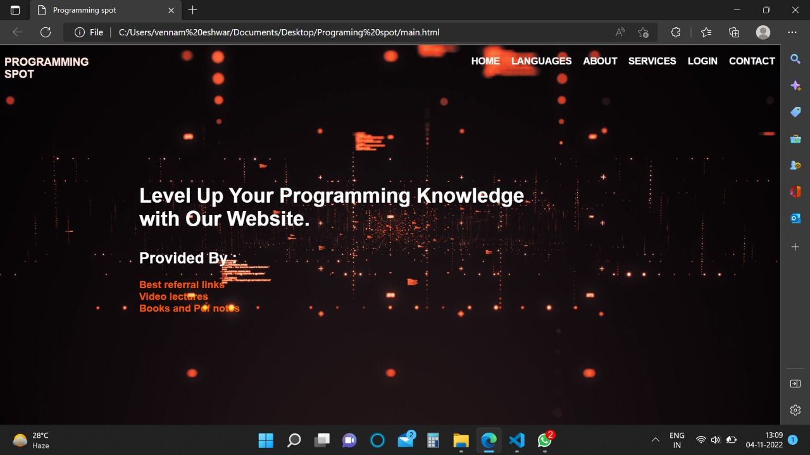

***Step 2:*** Here you can register by filling few details and later clicking register button.

* Username
* Email ID
* Password

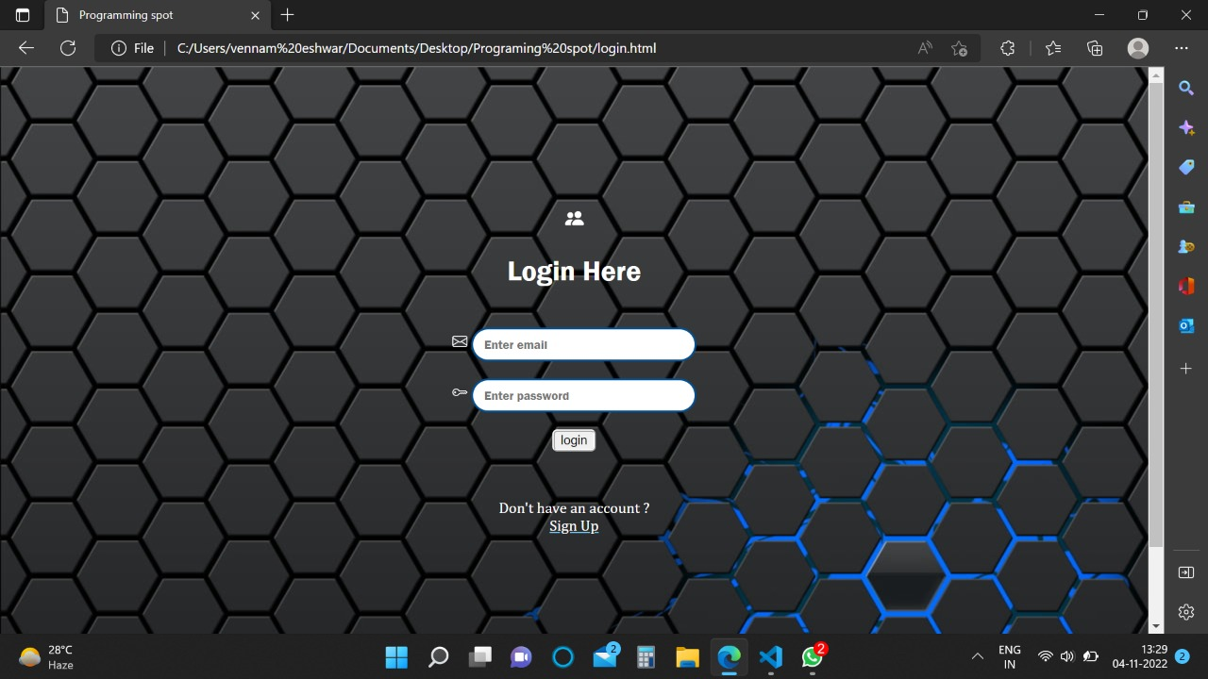

***Step 3***: Now you can find various languages of your choice and start learning it.

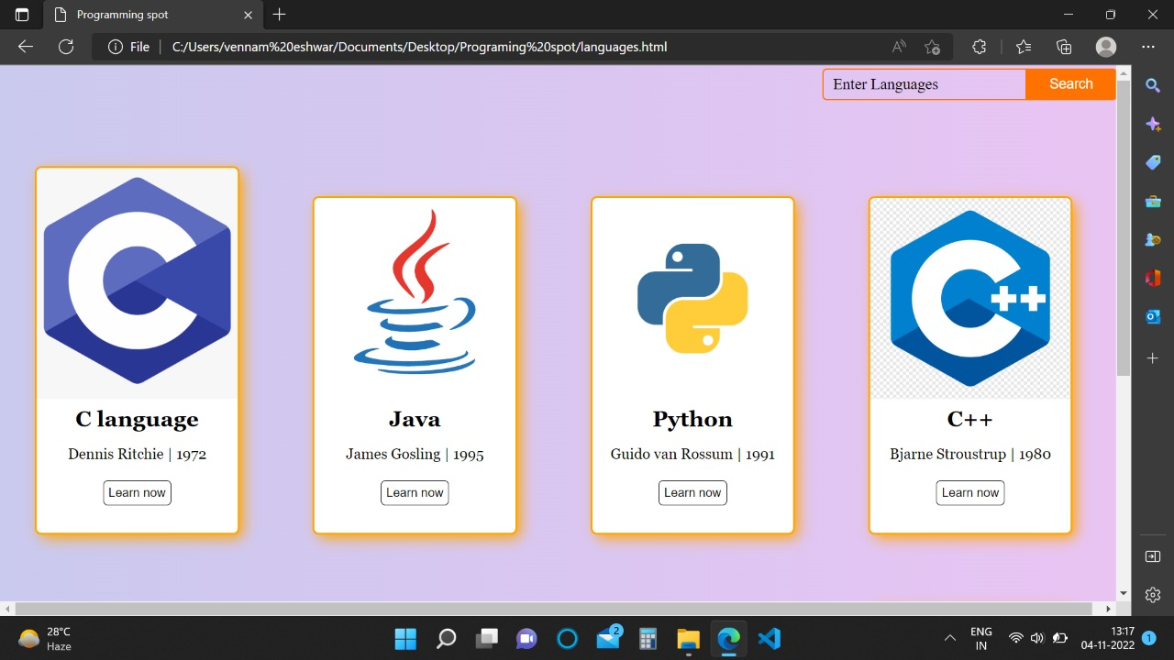

### CHAPTER 4 DESIGNING

* 1. **SYSTEM ARCHITECTURE:**

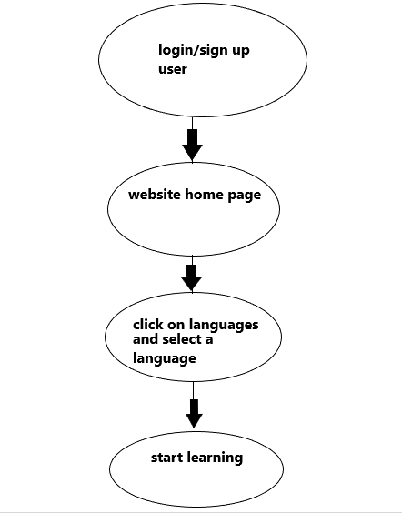

* 1. **SYSTEM DESIGN**

The design of a system is a model plan for the system includes

* + - context diagram
    - Entity relationship model.

#### Context diagram:

Context diagram also referred to as the Level O Data Flow Diagram, the Context diagram is the highest level in a Data Flow Diagram. It is a tool popular among Business Analysts who use it to understand the details and boundaries of the system to be designed in a project. It points out the flow of information between the system and external components. A context diagram makes part of the requirements document in a project. Unlike other project diagrams, the Context diagram is not for use by the engineers/technicians but the project stakeholders. It, therefore, should be laid out in simple and understandable language for easy understanding of the items by the stakeholders when they analyze it. A system context diagram represents all the external components that may interact with the system, hence displays the entire software system as a unit. This type of chart puts the system in the middle and surrounds it with its external parts, associated entities, and surroundings. Details of the interior structure of the system are explicitly left out.

This system involve three main entities (Admin, User).

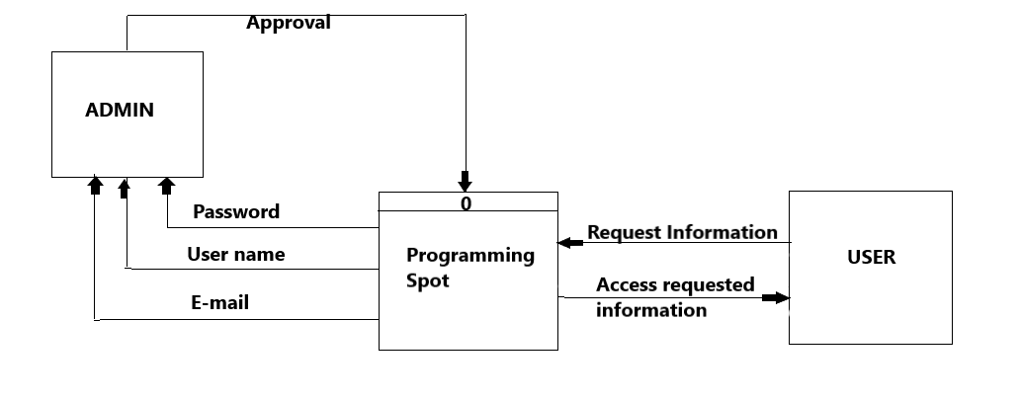

#### Entity relationship model:

ER model stands for Entity Relationship Model is a high-level conceptual data model diagram. ER model helps to systematically analyze data requirements to produce a well-designed database. The ER Model represents real-world entities and the relationships between them. Creating an ER Model in DBMS is considered as a best practice before implementing your database. It displays the relationship of entity sets stored in a database. In other words, ER diagrams help to explain the logical structure of databases. ER diagrams are created based on three basic concepts: entities, attributes and relationships. ER Diagrams contain different symbols that use rectangles to represent entities, ovals to define attributes and diamond At first look, an ER diagram looks very similar to the flowchart. However, ER Diagram includes many specialized symbols, and its meanings make this model unique. The purpose of ER Diagram is to represent the entity framework infrastructure.

The following figure shows ERD Diagram of Programming Spot website, Admin and User.

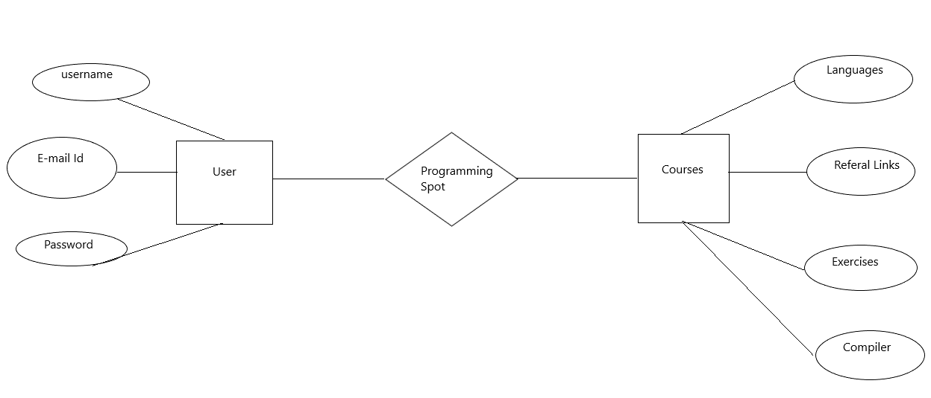

* 1. **ADVANTAGES**

# CHAPTER 5

**RESULTS AND DISCUSSION**

> This website is for free of cost

> It is online and available 24/7

> We also provide links to you tube

> For further advancement in topics we also provide links to the best rated

books

> We also provide compilers to practice then and there itself

> Our website interface is user friendly and good-looking colours are used

> Everything is handpicked to give users the best experience

### SCREENSHOTS OF EXECUTION

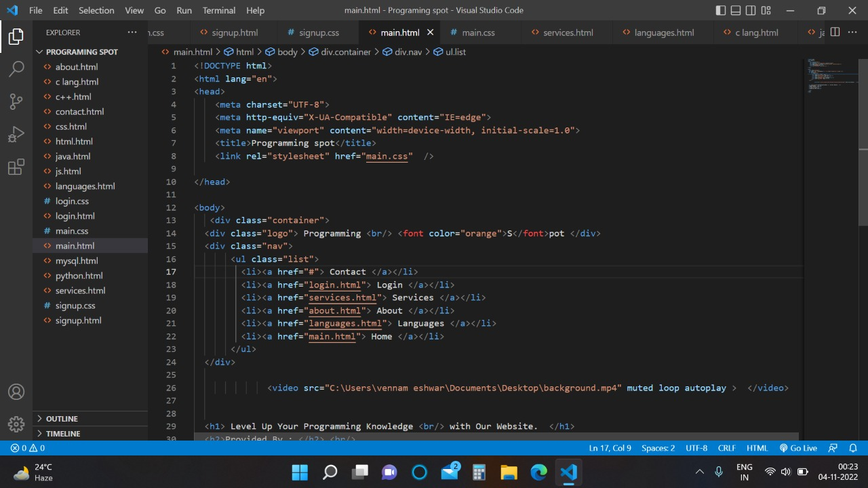

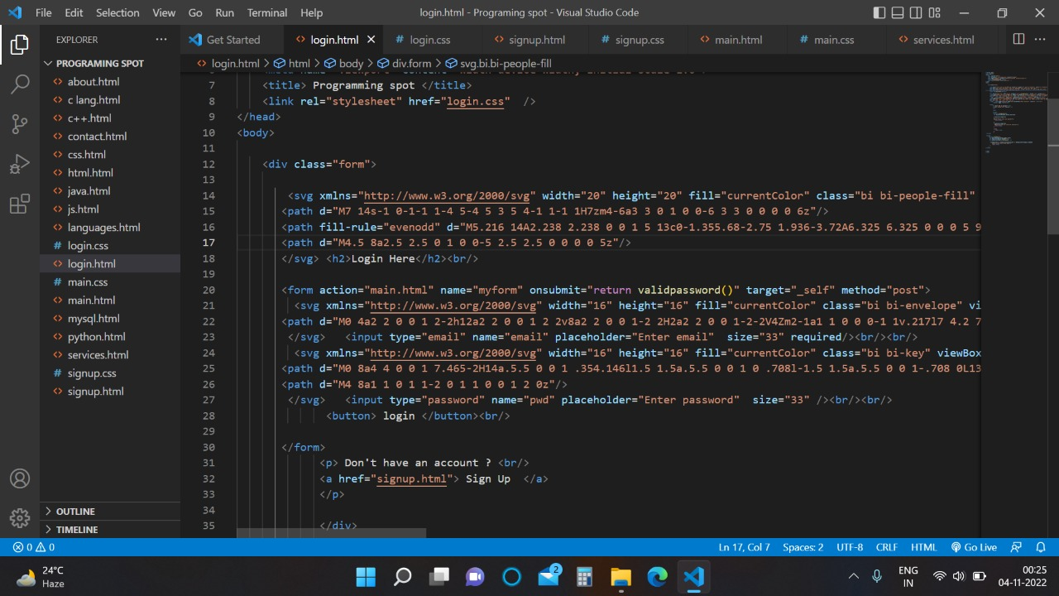

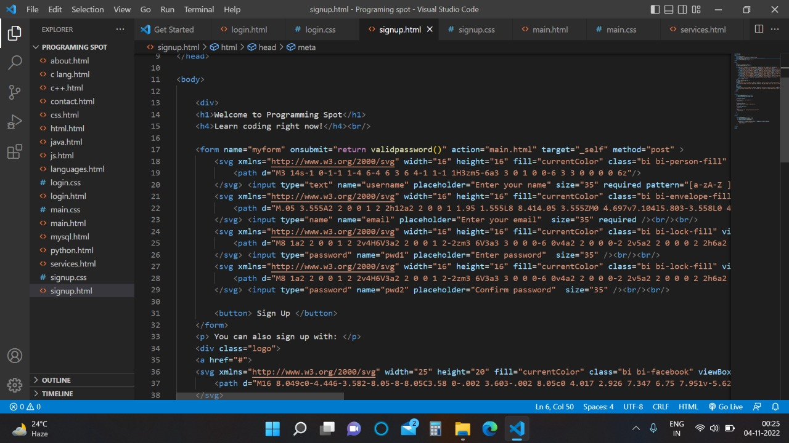

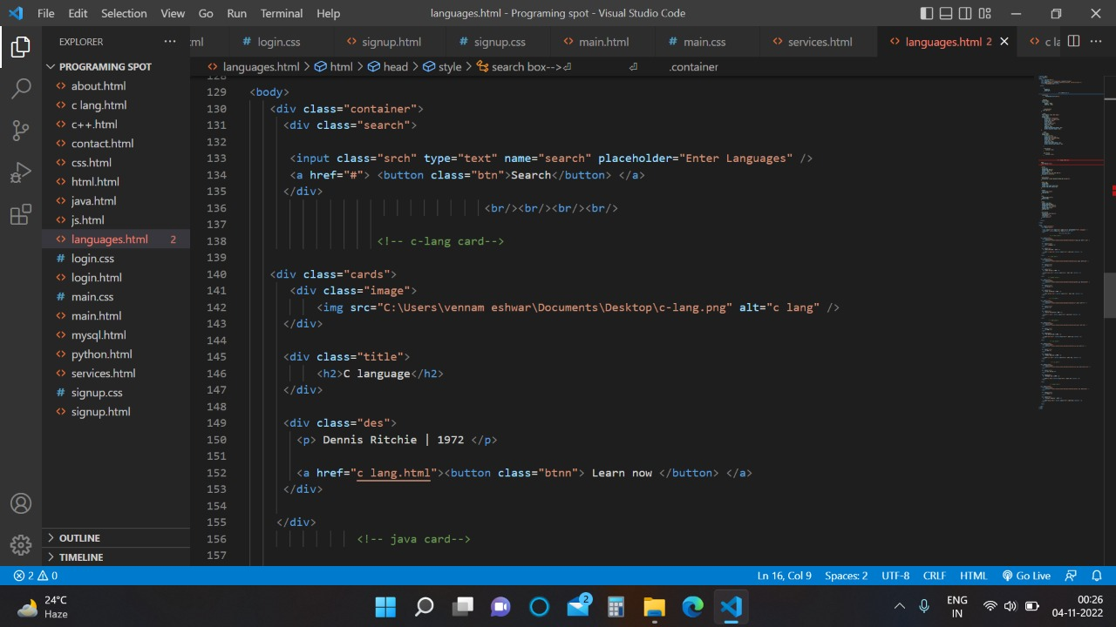

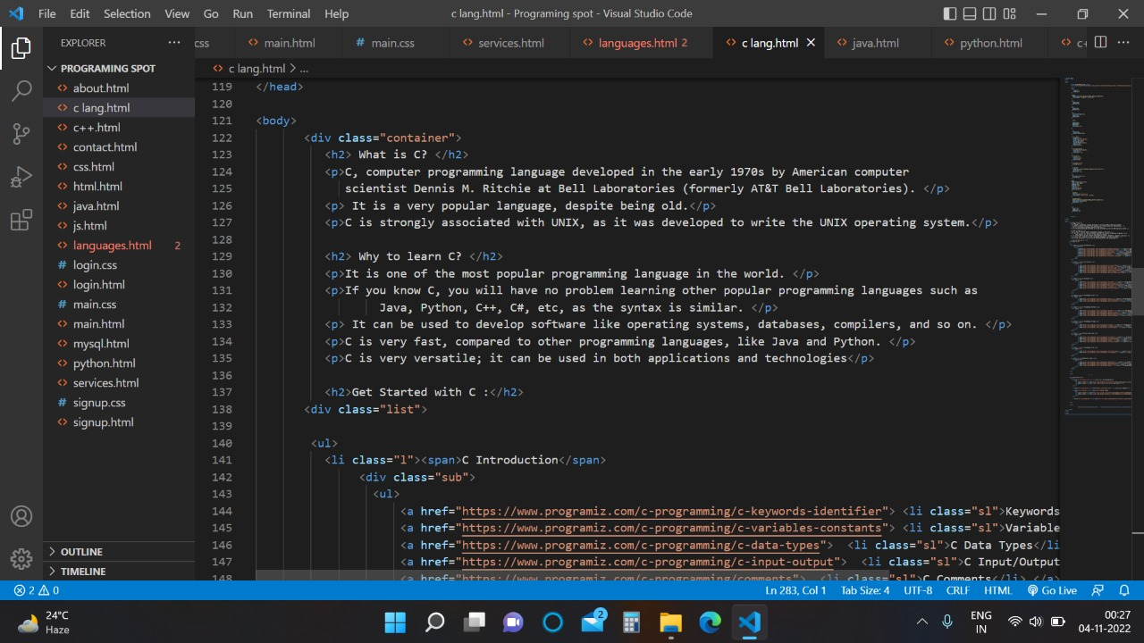

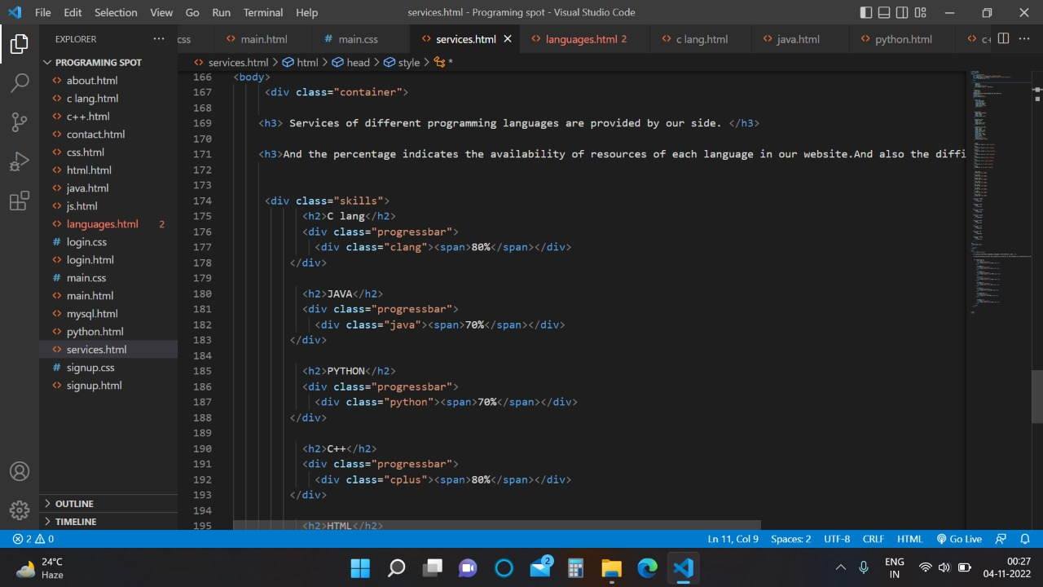

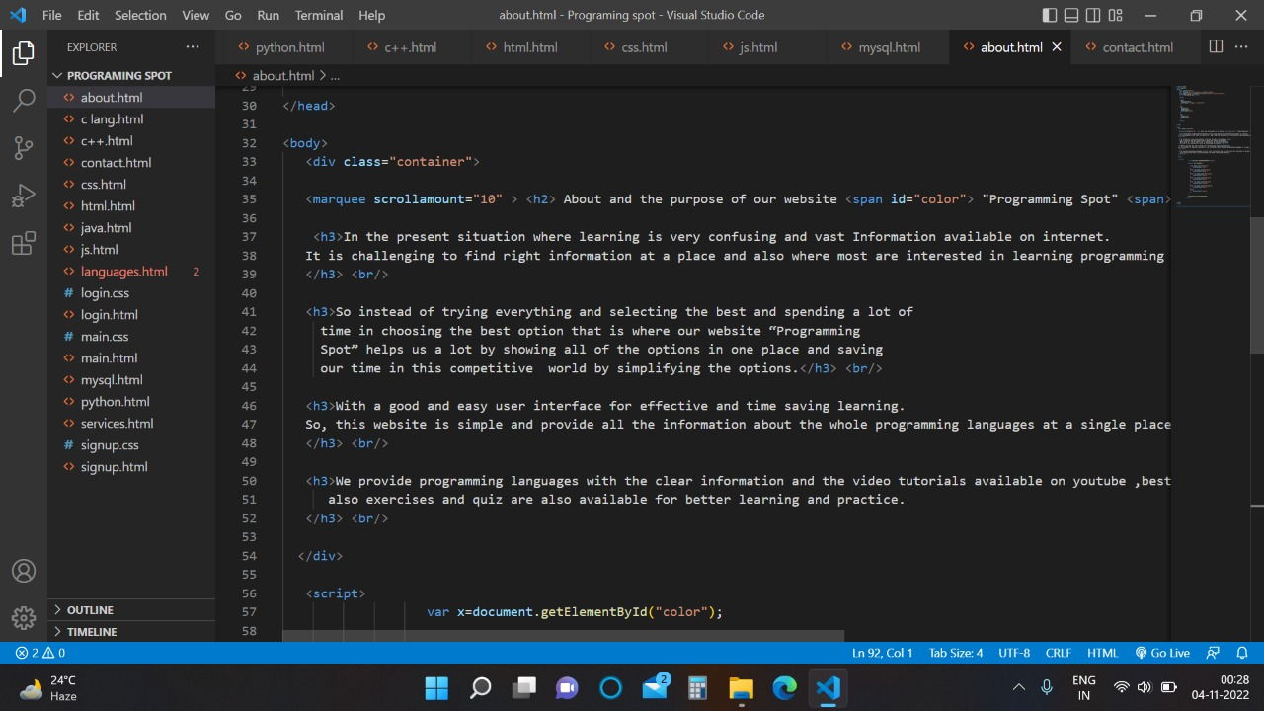

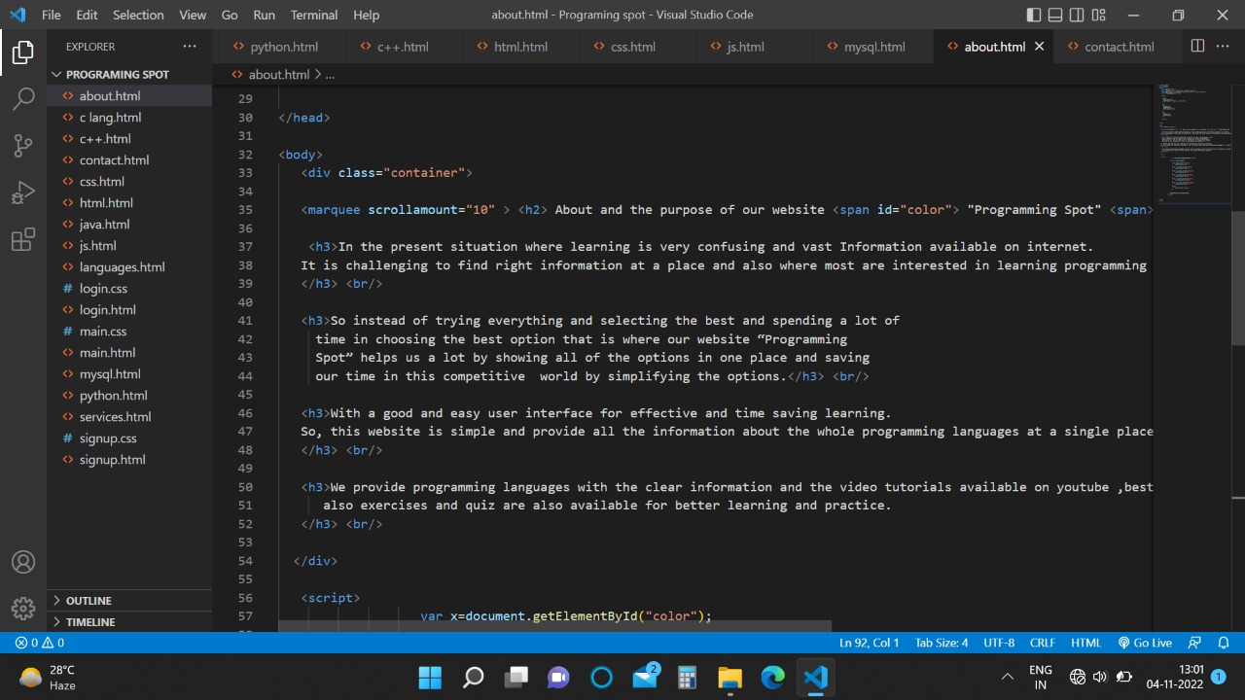

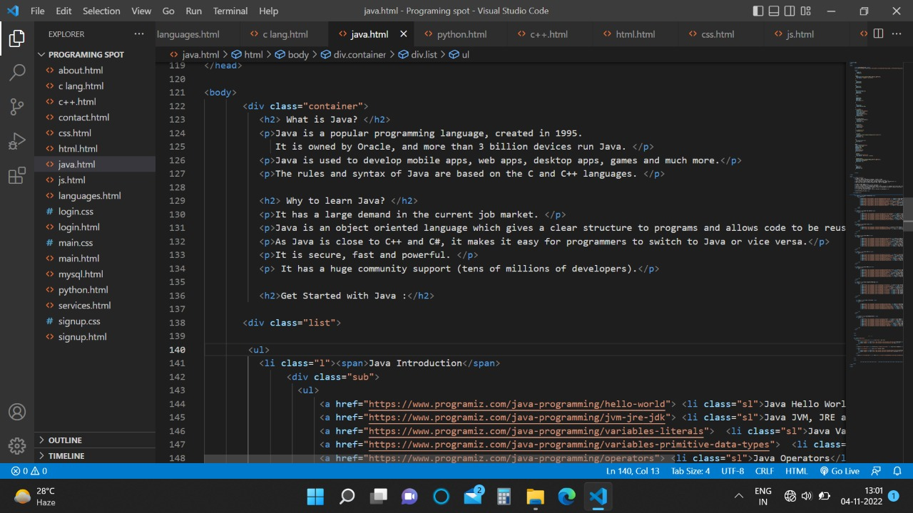

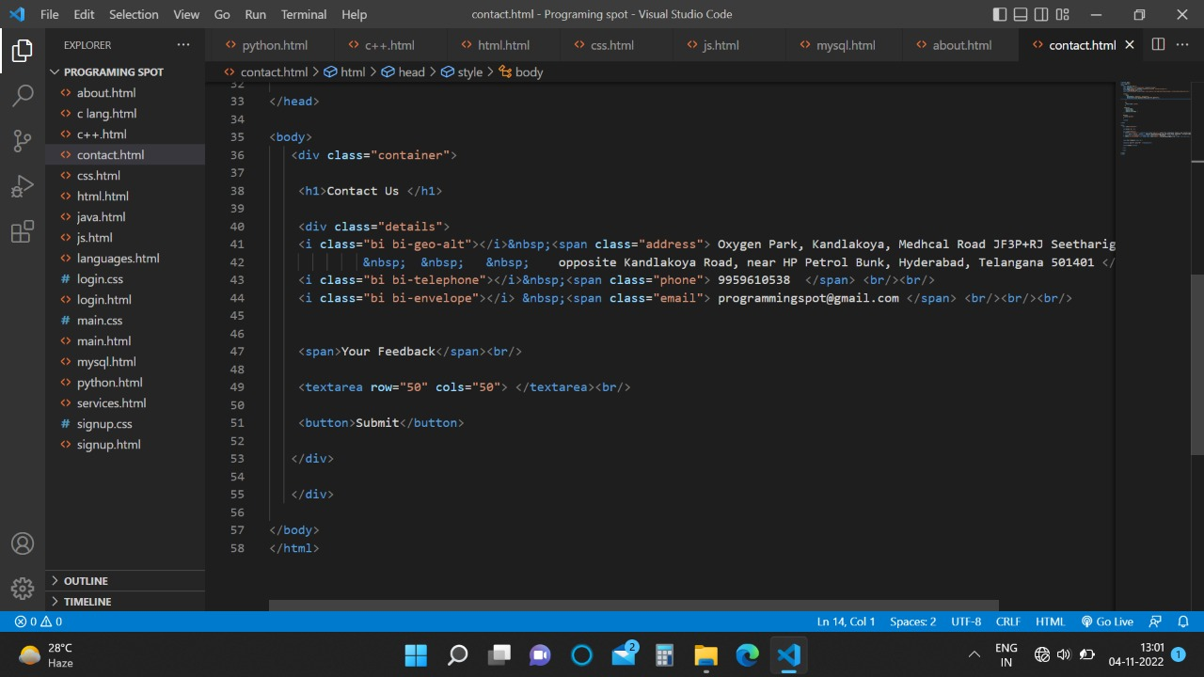

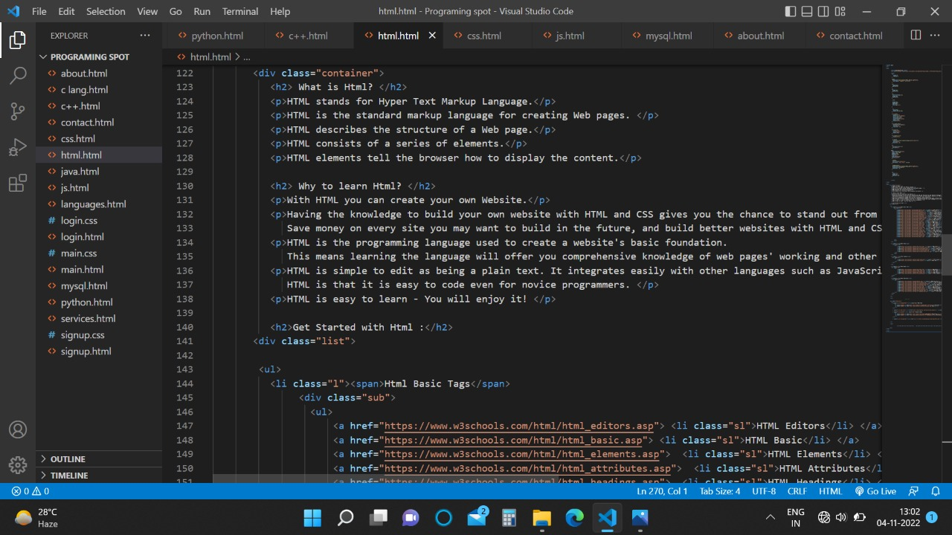

**CHAPTER 6 CONCLUSION AND FUTURE WORK**

We have come up with a website where it will feature a variety of options to learn programming languages, the students can access the website and learn any of the languages available with great clarity and less confusion. This website will have all the options required for the students to decide what to learn and do it in less time and access the links which will redirect us to you tube playlists which are very good.

Students can also buy the books which are suggested by us which help in advancements in topics. The information, hand written note and you tube playlists are all handpicked so that users don’t lose interest in learning

We would think of some modifications such as adding more features in our

systems like:

1.Modifying the Graphical interface (GUI) of the website and making it more user friendly.

2.An option for the consumers to login via their mail id, social media account etc.

3.We also have to create a database which stores our data and also user details.

# CHAPTER 7 REFERENCES

* You tube
* Google Chrome
* Microsoft Edge
* HTML, CSS and JavaScript Beginners guide by Jon Duckett.